A RARE CASE OF MYOCARDIAL ISCHEMIA CAUSED BY DESCENDING AORTA TO RIGHT INFERIOR PULMONARY ARTERY FISTULA
T.-H. Wu, C.-J. Wu
Department of Critical Care Medicine, Veterans General Hospital- Kaohsiung, Taiwan, Kaohsiung, Taiwan

Objective: Descending aorta to right inferior pulmonary artery fistula is rare and most frequently discovered accidentally without symptoms.
Case Presentation: We describe an 84-year-old male who had chest pain for 6 months with diagnosis of angina pectoris. Initially, he received coronary stent implanted; however, symptoms persisted. Descending aorta to right inferior pulmonary artery fistula with a lot of collateral circulation was found after obtaining of aorta computed tomography for evaluation of surgical bypass. After endovascular embolization by coli, his symptoms improved and all the collateral circulation was shut down.
Results: Due to myocardial ischemia caused by descending aorta to right inferior pulmonary artery fistula had never been reported, the physician should be aware that the descending aorta to right inferior pulmonary artery fistula can cause the symptoms mimic angina pectoris.
Conclusion: We should keep the possibility of angina pectoris caused by descending aorta to right inferior pulmonary artery fistula in mind to avoid unnecessary coronary stent implanted or surgical intervention to prevent potentially harmful inappropriate treatment.
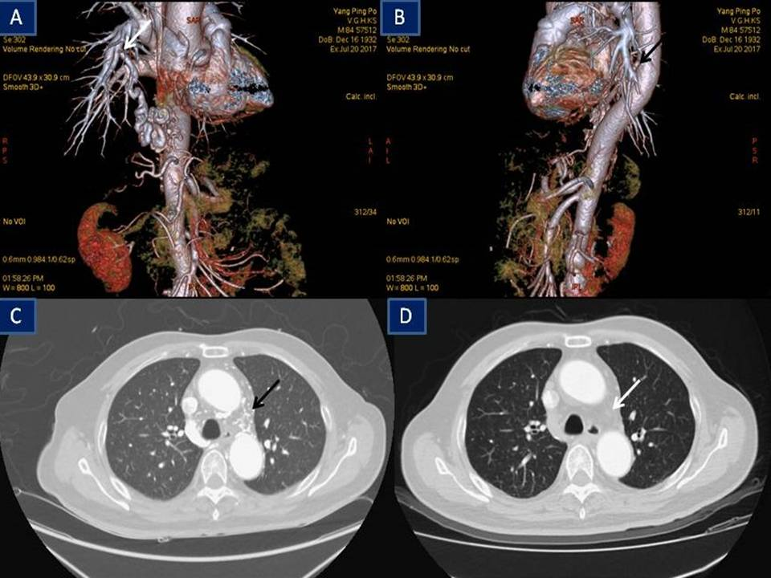
Figure 1. A. White arrow indicates the anastamosis of descending aorta pulmonary aorta fistula. B. The origin site of aorta. C. Chest CT shows a lot of collateral vessels (black arrow). D. After embolization, all the collateral circulation is shut down (white arrow).

